
Developer Guide:

Faculty. | Miss Maryam Mashood
Batch. | 2507f3
Cordinater | Miss Shazma Shaukat
 | Group members | Student ids
1. | Alyan Hassan | Student1680971
2. | Ali Touheed | Student1680973
3. | Shayan Hassan | Student1680974
4. | Hadi Rana | Student1683118
5. | Manaqib | Student1683237

Artisan Essentials – Website Documentation

1. Introduction
Artisan Essentials is a premium stationery shop offering branded products such as Moleskine, Pilot, Faber-Castell, Staedtler, Tombow, and more. The website features a modern interface with interactive product cards, filters, sorting options, search, and a dynamic shopping cart system.

2. Homepage
The homepage introduces the brand with a premium theme and elegant fonts. It includes a navigation bar, hero section, featured products, and quick access to the shop.
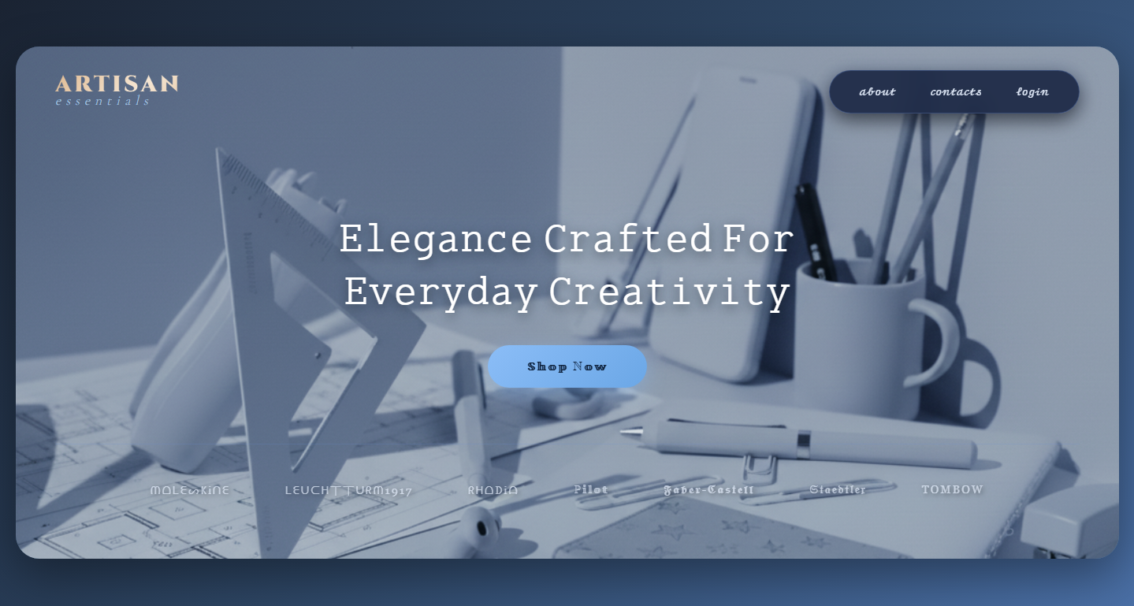
2. Homepage — Screenshot Overview

2. Homepage — Code Sections
HTML Code Section Placeholder:
CSS Code Section Placeholder:
JavaScript Code Section Placeholder:

3. Navigation Bar
The website features a fully responsive navigation bar with links to Home, Shop, About, and Contact pages. The cart icon dynamically updates based on user interaction.
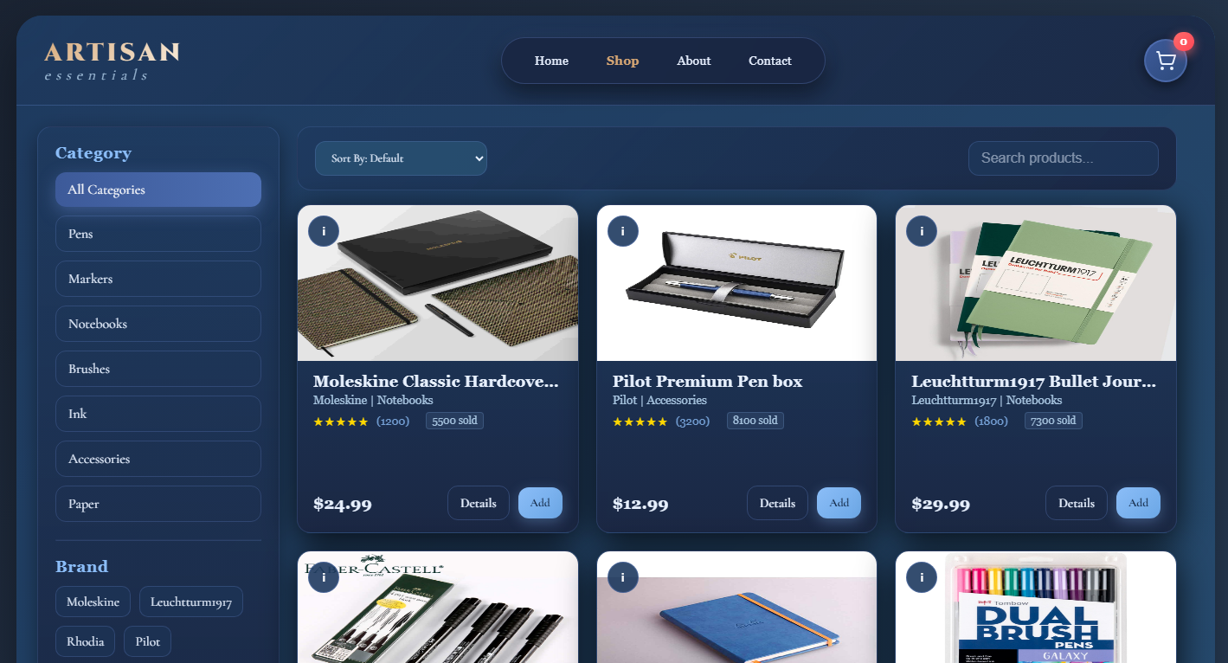
3. Navigation Bar — Screenshot Overview

3. Navigation Bar — Code Sections
HTML Code Section Placeholder:
CSS Code Section Placeholder:
JavaScript Code Section Placeholder:

4. Shop Page
The Shop page is the most interactive section of the website. It includes category filters, brand filters, search bar, sorting options, dynamic product cards with flip animations, product modals, and a shopping cart sidebar.
4. Shop Page — Screenshot Overview

4. Shop Page — Code Sections
HTML Code Section Placeholder:
CSS Code Section Placeholder:
JavaScript Code Section Placeholder:

5. Product Cards
Each product card displays title, brand, category, rating, price, sales count, and options for adding to cart or viewing details. Cards include a front and back side with smooth 3D flip animation.
5. Product Cards — Screenshot Overview

5. Product Cards — Code Sections
HTML Code Section Placeholder:
CSS Code Section Placeholder:
JavaScript Code Section Placeholder:

6. About Page
The About page explains the brand's mission, craftsmanship, and attention to quality. It maintains a premium visual identity to reflect the brand’s tone.
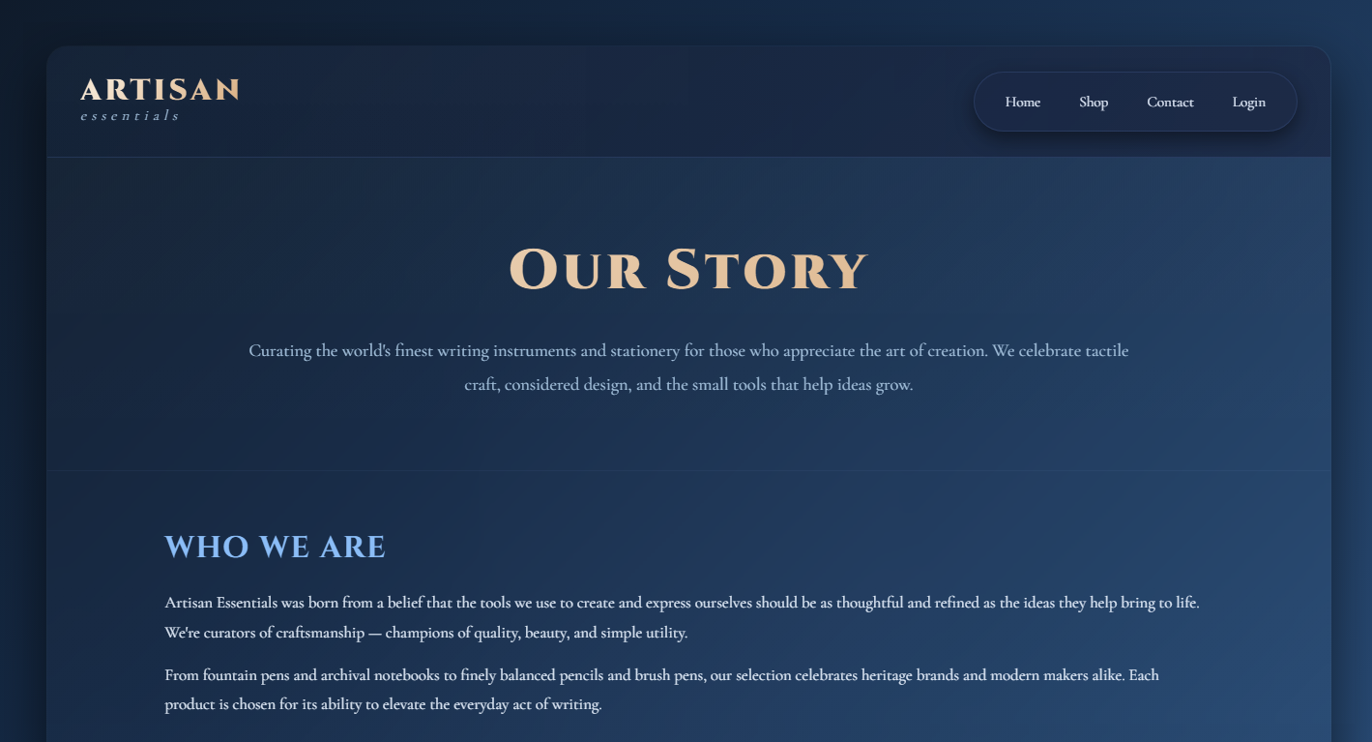
6. About Page — Screenshot Overview

6. About Page — Code Sections
HTML Code Section Placeholder:
CSS Code Section Placeholder:
JavaScript Code Section Placeholder:

7. Contact Page
The Contact page contains a modern contact form, social links, and store location.
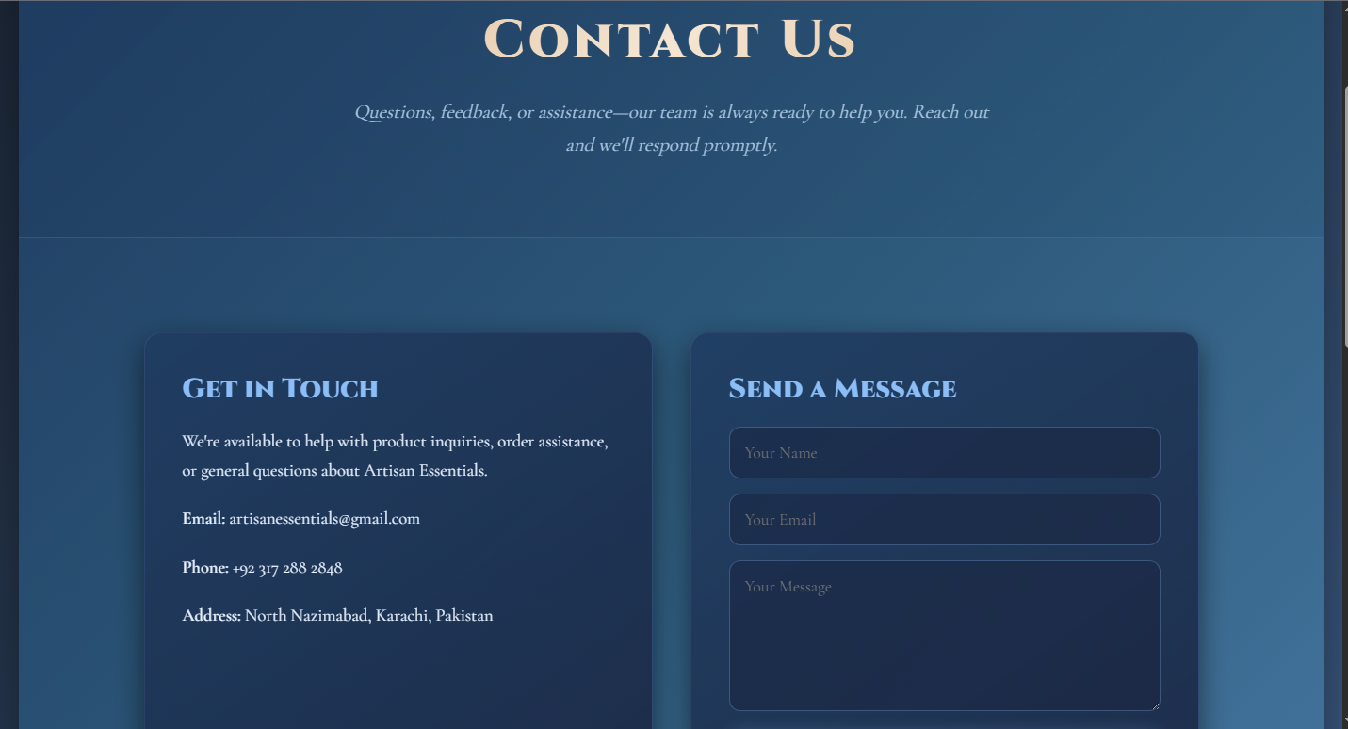
7. Contact Page — Screenshot Overview

7. Contact Page — Code Sections
HTML Code Section Placeholder:
CSS Code Section Placeholder:
JavaScript Code Section Placeholder:

8. Footer
The footer contains essential information including quick links, social media, contact details, and copyright.

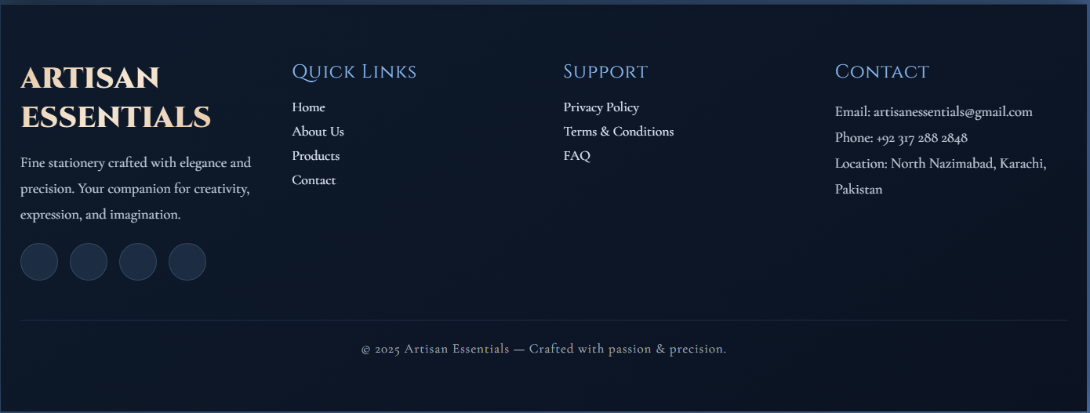
8. Footer — Screenshot Overview

8. Footer — Code Sections
HTML Code Section Placeholder:
CSS Code Section Placeholder:
JavaScript Code Section Placeholder:

9. Summary
The Artisan Essentials website presents a clean, modern, and premium browsing experience with excellent user-friendly features.

